Table of Contents

**1 HDFS Case ID** 2

**2 IBCS control Sheet** 2

**3 IBCS Weekly status calls** 2

**4 IBCS Application Overview** 2

**a)** **IBCS Application Flow** 2

**b)** **Folder Structure in the Application** 3

**d)** **Technology details** 3

**e)** **SQL Jobs** 4

**f)** **Windows Services** 4

**5 Master Module Overview** 4

**6 Import Module** 10

**Reports** 11

**XML Generate** 16

**7 Export Module** 17

**8 Business impact** 18

# **1 HDFS Case ID**

If all such scenarios where we receive any urgent issues, HDFS case Id is to be created either by us or we might even receive an already prepared case Id from business over mail.

In order to proceed with any change on the production server we need to create a change request from CCManager and get the approval of the same from the concerned person in the hierarchy (i.e. Mukund)

After this we can proceed with the change and get approval of the concerned business user (Venkatesh) and get this issue resolved.

Note: - In normal cases (i.e. not urgent per say) we can directly proceed with CCManager (Change Request), without creating any HDFS case ID

# **2 IBCS control Sheet**

This is an excel sheet which is internally managed by the team to keep track of all the issues raised and solved

# **3 IBCS Weekly status calls**

There is a scheduled call at 1PM every Tuesday, for which there is a general practice to prepare all the relevant points pertaining to the discussion beforehand on OneNote.

# **4 IBCS Application Overview**

# **IBCS Application Flow**

UPS India uses IBCS (India Border Clearance System) for pre-clearance activity to assist UPS to get shipments custom cleared.

There are two existing process which are Import process and Export process

All these imports and exports are processed through three Indian ports namely Delhi, Bombay, and Bangalore

**International Transport Process**



The international transportation process comprises of both import and export processes.

UPS India uses IBCS (India Border Clearance System) for pre-clearance activity to assist UPS to get shipments custom cleared. IBCS is custom build solution for India subsidiary considering the nature of business and custom regulations.

# **Import Process**

## **Low Value Import Process**

Shipments information flows from DIAD, Worldship, IBC and also key entered in the OPSYS system by origin country users. UPS India brokerage team accesses the same to process through the IBCS system. Below diagram explains workflow of low value shipment pre-clearance activity using IBCS.



1. **User creates Level1 file for a SLIC** (Ex. Bombay SLIC 0109): For import operation, inbound shipments manifests are selected for file creation. Usually, user selects shipments for 3 to 4 days in future so as to keep them ready for clearance when they actually arrive in India.
2. **Download a Level1 file to local machine**: Since there is no direct interface between IBCS and OPSYS, users use a Global Shipment Status Update (**GSSU**) application to download file from OPSYS and store it in a local machine. At this level shipment-to-flight mapping is not done and shipments are not scheduled to fly.
3. **Upload and Merge Level1 file to IBCS**: This process includes uploading a Level1 file to IBCS and merging if for a Flight Number and Date.

At pre-clearance stage, since a flight number is unknown, **Virtual Import** flight is selected. With this user can process future shipments and keep them ready when they come to India. On merging Level1 file with IBCS, system presents summary of all the shipments in it. Shipments are categorized based on

* Type of Shipments
  + Non-Document
  + Document &
  + Letters
* Slabs
  + CBE XII ( *for shipment value up to INR 10000* )
  + CBE XIII ( *for shipment value between INR 10000 to INR 100000* )
  + CBE XIV ( *for shipment value more than INR 100000* )
  + NA

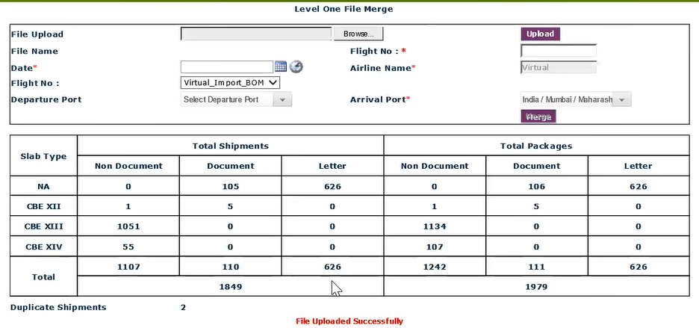

Pre-clearance activity is not done for Document and Letter type shipments as Customs do not need much documentation of them and are processed smoothly compared to Non Document shipments. However, they must be declared with the Custom.

The Custom Bill of Entry (CBE) slabs are decided based on the value of shipments and type of shipments. Filing process differs across these slabs for documents and declarations. Shipments with value more than INR 100000 but in courier mode i.e. CBE XIV shipments are processed under low value formal clearance i.e. “Low value BOE” process. On the other hand CBE XII and CBE XIII shipments are processed through normal import pre-clearance process.

Though shipments are classified based on CBE slabs by the system, each shipment is supervised by the brokerage team to cross-check correct classification as wrong classification may incur penalties to UPS.

1. **Flight Processing**: This process helps to process shipments for a particular flight and divide them into Documents and Non-Documents. This is a repetitive process and can be done at the merging stage itself.
2. **Pre Clearance**: The pre clearance activity starts at this stage. Based on the predefined rules set in Rule Master, shipments are classified into Frontline and Backline buckets. Frontline contains shipments which satisfies all the business rules set in the rule master. However, they still go under scrutiny and if the user finds that information is missing for custom clearance or more information is needed, they are moved to backline. Backline contains shipments which are missing some crucial information needed by customs such as IEC code, GST number or other KYC details.

Each shipment in the Frontline view is reviewed by Raters *(Raters are users responsible for processing shipments in Frontline view. They have knowhow of custom’s processes and regulations)*. They check invoice terms, IEC Code, GST Type, State Code, MEXIM or HS Code, Custom Duty structure etc. They also verify documents from **IDIS** application to verify that the documents are present for the information provided as these documents need to be provided to customs.

If Raters find any data missing or documents not available for the provided data, they move shipments to backline view. Backline team then reach out to the customers and seek required information. Once they receive all the required information, Backline team changes status of the shipment as “Ready for Clearance” and move shipments back to Frontline.

When shipments have all the required data and documents needed for custom clearance, Frontline users change shipment status to “Ready for XML”.

1. **Actual Flight Processing:** XML files are generated for the actual flights and not for the virtual flights as custom needs information for shipments coming in a particular flight. So, when a flight departs from origin, origin sends a pre-alert. On receiving alert, brokerage team generates Level1 file from OPSYS for the flight and uploads it to the IBCS.

The newly uploaded file have shipments only for a particular flight and they may be classified as below

* Shipments which are already processed using virtual flight – IBCS move such shipments to actual flight as they are ready for filing.
* Shipments which are new and not went through pre-clearance process yet – Such shipments need to go through pre-clearance process.
* Shipment which have processed through virtual flight but the data is changed – For such shipments, IBCS overrides data from actual flight to virtual

1. **Generate XML**: Once shipments for a particular flight are processed in IBCS, user imports all “Ready for XML” shipments and generate XML (schema is provided by the Customs)
2. **Get Invoices from IDIS**: For all the shipment numbers invoices are fetched from IDIS to be submitted to the customs
3. **Upload XML to the ECCS FTP Location**: Once XML and Invoices are ready they are uploaded in the ECCS FTP location.

## **High Value Import Process**

All CBE XIV shipments with value more than 100000 INR are automatically parked into “Low Value BOE” bucket. These shipments need special processing as the documents and information needed by the Customs varies compared to CBEXII and CBE XIII.

For processing each shipment through IBCS user needs to fill following details

* Shipment information
* Courier
* Customs House Agent
* Importer
* Bill of entry category
* High sea sale
* Flight, Origin and Destination
* Import General Manifest
* Bonds if any
* Procurement details if any
* Invoices including duty and exemptions if any

For a particular shipment, once above information is entered in the system, a checklist is generated and shared with the customer for confirmation. The checklist is a draft copy of Bill of Entry which has information about duty structure, respective amount and total applicable duty. Customer needs to approve the declaration in the checklist. By approving the checklist customer agrees to pay the duty amount.

Once the checklist is approved by the customer, user changes the shipment status to “Confirmed” and generates the XML. Finally the XML is uploaded in ECCS FTP location.

# **Export Process**

The export function of the system is still under UAT. Below process explains high level To-Be process of export operation using the IBCS system.



* To process Non-doc export shipments through IBCS, Brokerage user needs to upload Level1 file from OPSYS and shipment scanned from Tundra. The Tundra file contains information about Bag or ULD number and Load number for a shipment. This step is important as shipments are bagged and cleared as bags from the customs.
* Merge Files: Once uploaded, two files are merged in IBCS. IBCS creates shipment records in the master data from Level1 file and assign Load, ULD information from Tundra file.
* Flight Processing: User selects a flight and checks whether number of shipments, ULDs and status of shipments are as expected. User can also change status of the shipment or transfer shipments from one file to another.
* Get Invoices: User then gets invoices files from IDIS system for all the shipments. These invoices need to be submitted along with XML file to ECCS.
* Upload files: User uploads CSV files for GST and IEC data for CBE IV and CBE V shipments. User can also upload shipments which are missed by the key entry team and missed scans by the operations team.
* Update flight: Once the flight information is available, flight is updated with the Master Air Way Bill number.
* Generate XML: Once all the Non-Doc export shipments are in “Ready for XML” status, user generates XML file and uploads in the ECCS FTP location along with invoices files.

# **Folder Structure in the Application**

App_Code Folder- This folder contains all the class files. Similar to business layer

Download Images Folder- This folder contains all the images downloaded from ftp server. DIS Service downloads images to this folder from FTP Path

ExpModules - Web forms pertaining to export Module

ExpReports – Contains Crystal reports from SAP, was used earlier (Now SSRS is implemented)

External data – All the XML and CSV files which are generated are saved over here

Images- Contains all the images used in the application

Includes- Contains all the images used in the application

Master- Contains web forms for masters modules

Modules- All forms under Import Modules such as Frontline Form, Backline Form, LVBOE Form, and XML Form are present here

New Images – All the images after conversion are saved over here i.e. the .tiff images (DIS Service)

Reports – Contain Crystal Reports (.rpt files)

SysAdmin – Login Page (Application’s Login Page)

XSD Schema – Schema File (.xsd). CSB 3, 4, 5. CBE4, 5. Schema to generate XML

Root Folder

ABC text file - Application logs are kept over here.

BoCSys_Menu – Contains Master Page. (All menus listed on the master page are not hard coded rather they are bonded from database as per the roles)

IBCS Services (3 Import and 3 export services)

A team from Conduent pushes files to our SFTP server.

DIS Service downloads images from server to our downloads folder and then deletes the same from SFTP server

Level 1 files are present on ftp server, OPsys service copies these files to application folder

Merge Service merges all the images which are downloaded.

Purge Service deletes data which is lying on server for more than 60 days be it reports, images or XML.

1. **Environment Details**

Database Environment

* QA
* UAT
* BETA
* PROD

Application Environment

* QA
* UAT
* BETA
* PROD

# **Technology details**

* Programming Language
  + C#
  + Windows Services
  + SQL
  + HTML, CSS, JavaScript
* Reporting Tool
  + SSRS
* Operating System/Database
  + SQL Server 2014
  + Windows Server 2016 R2 Standard
* Framework
  + .Net Framework 4.6

# **SQL Jobs**

# **Windows Services**

# **5 Master Module Overview**

Company Master – Registration details of the company

Details of TAX

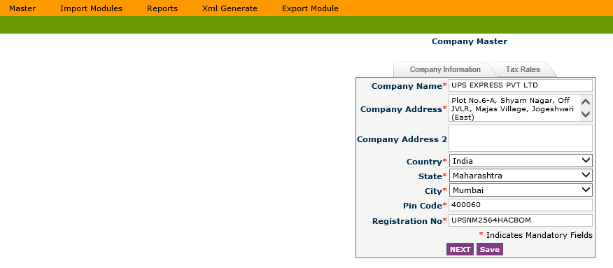

User Master- Details of types of user

Admin, Agent, Bangalore User, Delhi User, Bombay user, rater, Supervisor

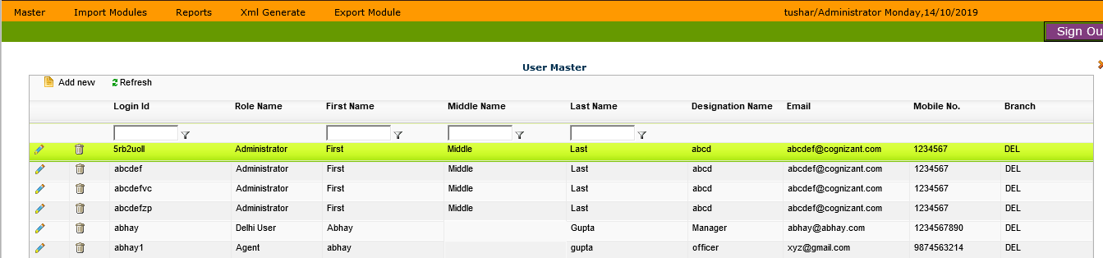

Country Master- This contains the names of all the countries with their corresponding codes.

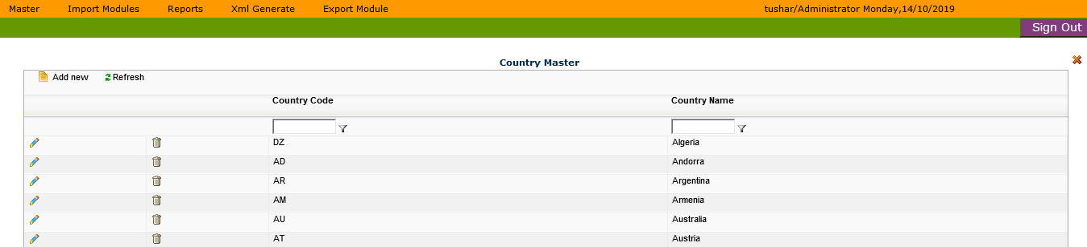

State Master – This contains the names of all the countries, states with their corresponding codes.

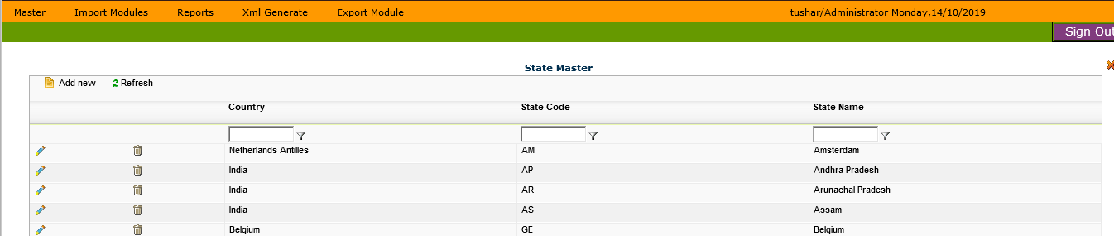

City Master- This contains the names of all the countries, states and the city name.

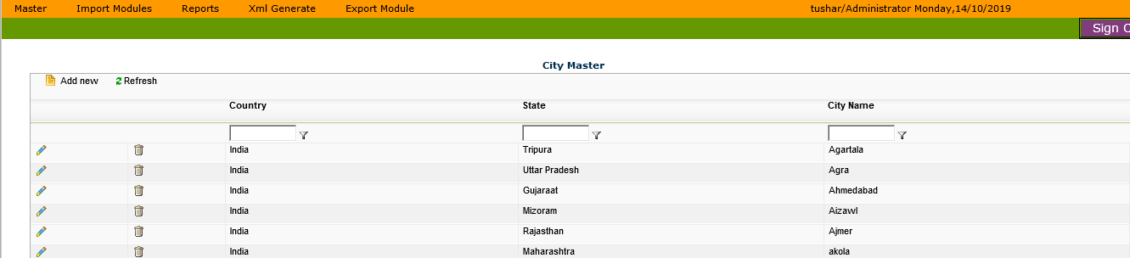

Branch Master- This contains the names of all the branches, addresses, branch registration number, city, state, pin code etc.

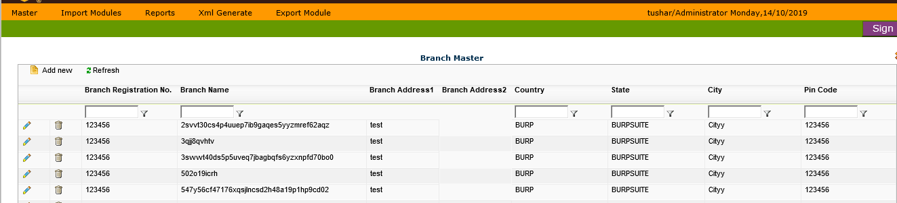

App Settings

This can be used by admin user to change the path of the ftp server

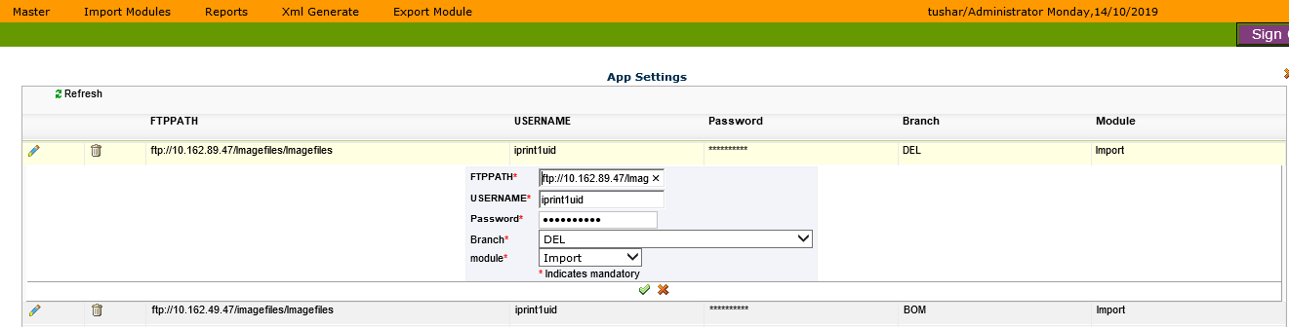

Currency Rate Master- This contains information about Currency Code, Country, and Description, Exchange rate with respect to INR and exchange rate with respect to US Dollar (USD).

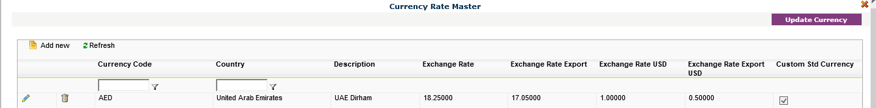

CTH Master (Custom tax head master) – This contains the information about the custom duty to be applied for a specific type of consignment

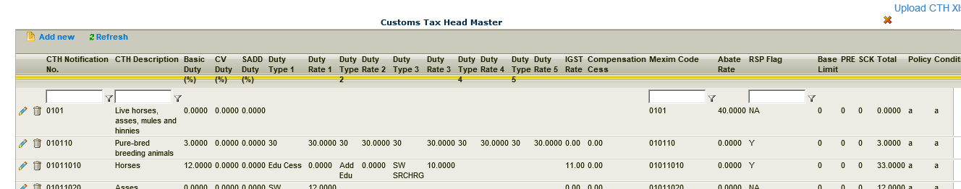

Duty Master- This contains information about type of invoice in order to apply appropriate duty, freight charges, insurance, load charges.

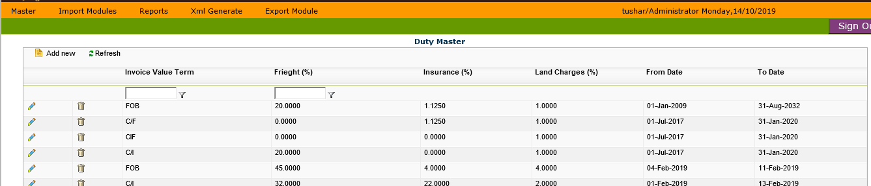

Notification Master- List of notifications.

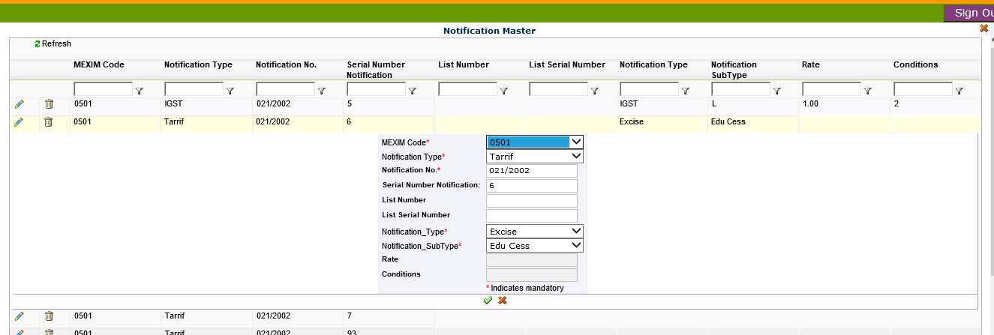

Pin code Master- Contains all pin codes for various cities.

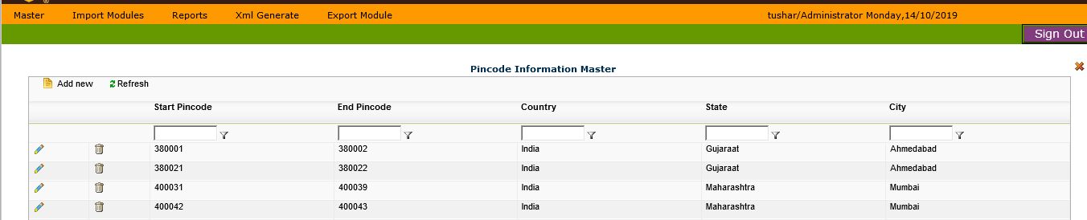

Port master- Contains information of various ports

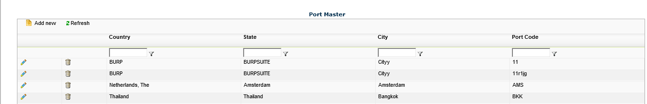

SLIC Master (Standard Location Identification Code) – Unique SLIC codes corresponding to each city. Each SLIC code has a range of pin codes, as SLIC Codes are mapped against a particular city which in turn can have many pin codes area wise.

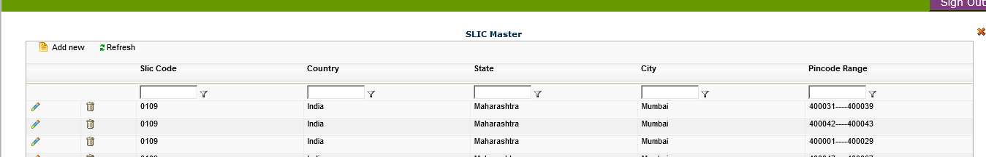

Duty Structure Master- Contains structure for duty charges.

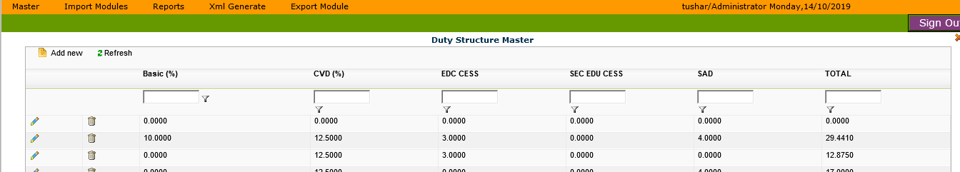

Consignee Master- Contains Consignee details, Account Number and company name

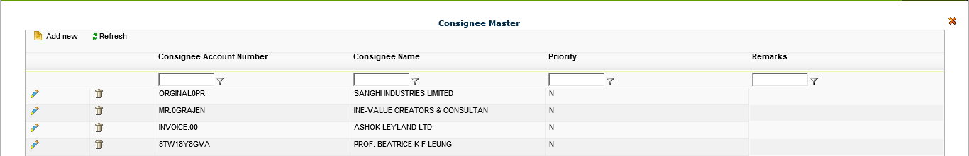

IEC Master

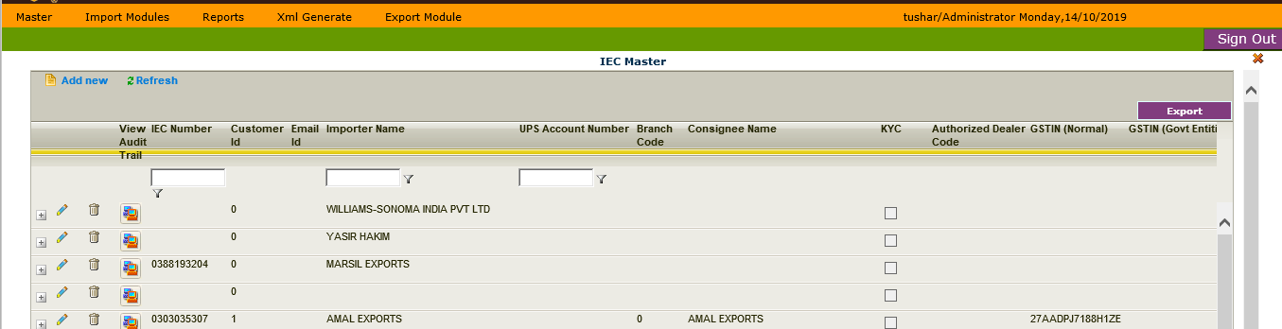

Rule Master- Contain various rules.

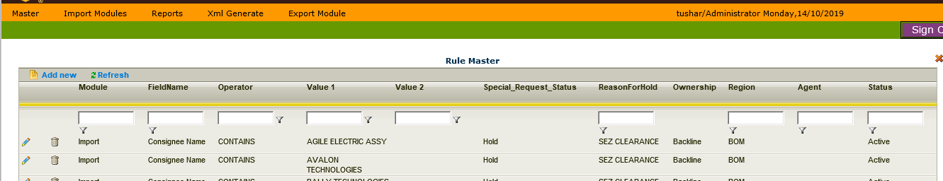

Flight Master- Flight Number, Airline, Time, Type, Departure Port, Arrival Port

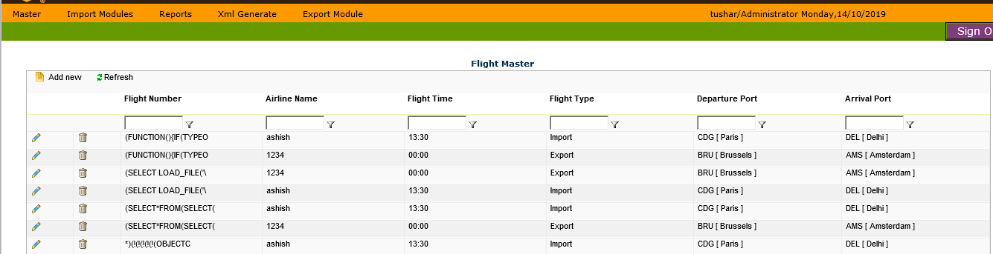

Invoice Slab Master- Based on amount of product (e.g. CBE 12, 13, 14) 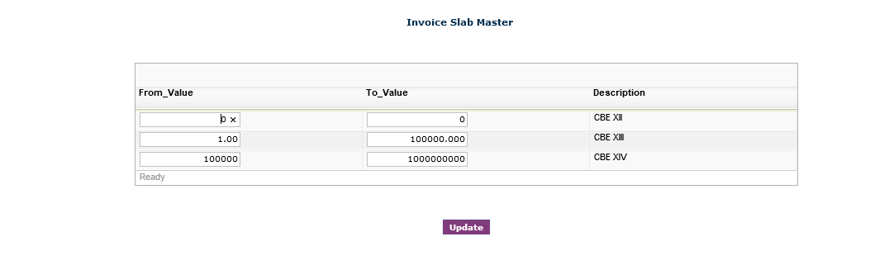

Reasons For hold Master- Multiple listed reasons

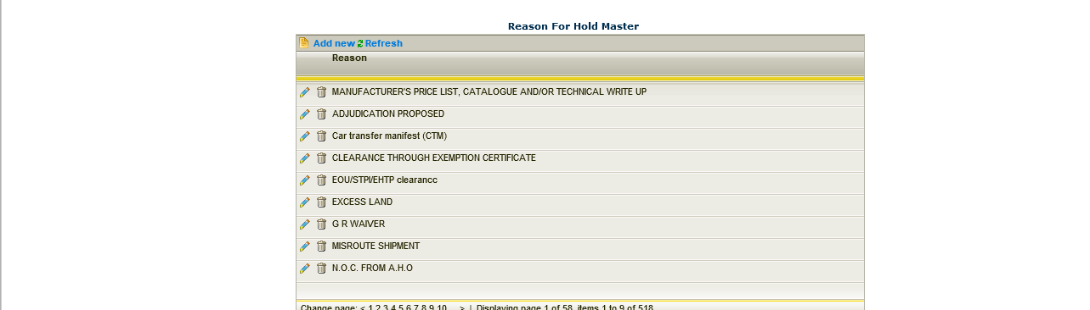

Load Master- Load area, Country, Port, Flight, and State

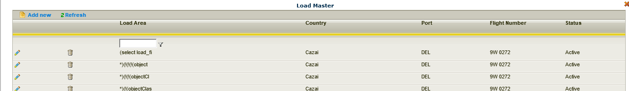

Roles and Responsibilities Master- User Roles (Agent, Admin, rater, Supervisor, Delhi User etc.)

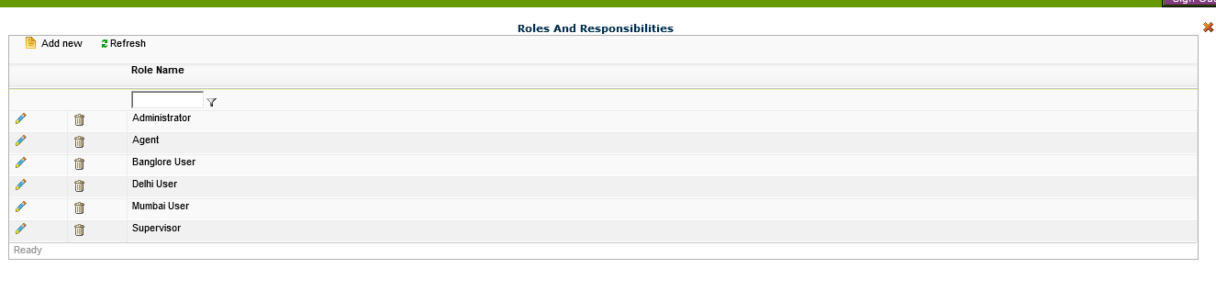

Custom house Agent Master- License name, Address

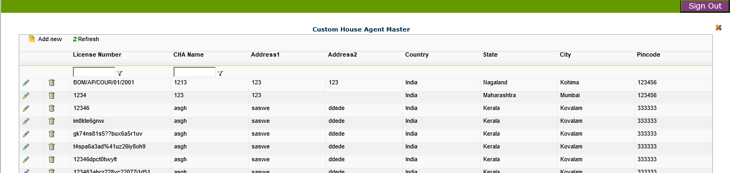

# **6 Import Module**

Flight Processing – In order to transfer shipment to another flight (flight to flight transfer)

Shipment can be searched via flight number and shipment number.

DIS Integration- Flight number can be selected and then merge button is used to merge.

Only the pending statuses are displayed.

Data issues for a particular file can cause it to stop for all.

File Merge Mapping

SQL Job enters all file names into this table

Table name – Tbl_Level1File Details

We can also change flight number for the particular shipment.

Transfer Shipment Screen – Not clear

LVBOE (Low Value BOE)

Rating can be done here

Search via flight number, shipment number

Generate Button – not clear

Add Shipment – This is disabled

Frontline Screen

All the shipments which are ready for clearance are displayed here.

Rating can be done here

Generate TRb Report – Not clear

Upload Button – Not clear

Generate Rating status - Not clear

Backline Screen

All the shipments with status as hold are displayed here

Shipments can be moved to frontline from this screen, we can mark this via Data entry > Special request > Ready for clearance

Export Button- Generates XML

Assign Agent Button – Can assign agent to shipment

Postal Code Update

Postal codes can be updated from this screen.

Select flight number> Select Shipment>Update postal code.

# **Reports**

Report Viewer

Crystal reports were used earlier but now SSRS reports are used as most of the reports are migrated to SSRS except for manifest which is yet to be migrated.

It has 2 modules

1. Import –

Checklist Report

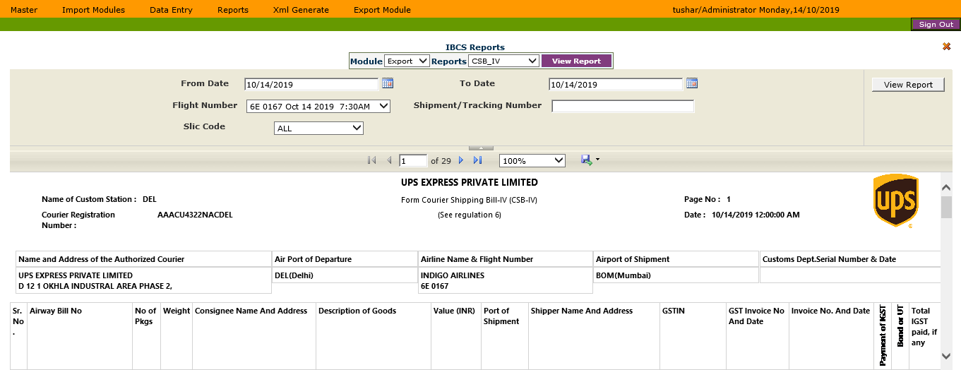

HAWB Print Report – not designed?

KYC Compliance Report

* Status of KYC Compliance

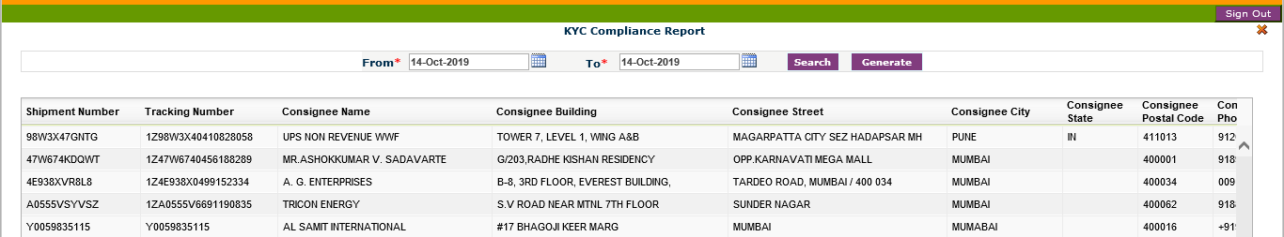

No Invoice Report

* All reports for which invoice not generated are displayed.

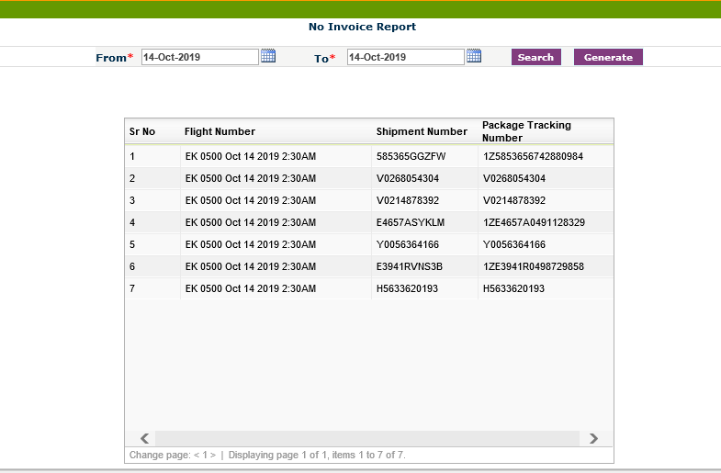

EDI Response Report

* Listed reasons for which invoice not generated.

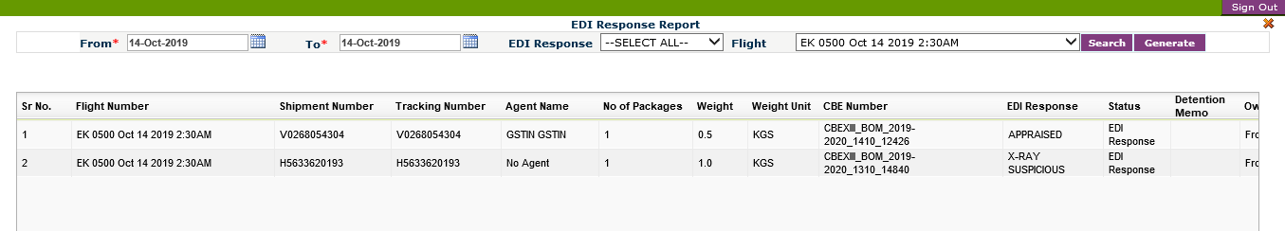

Shipment Reports

* Shipment related details

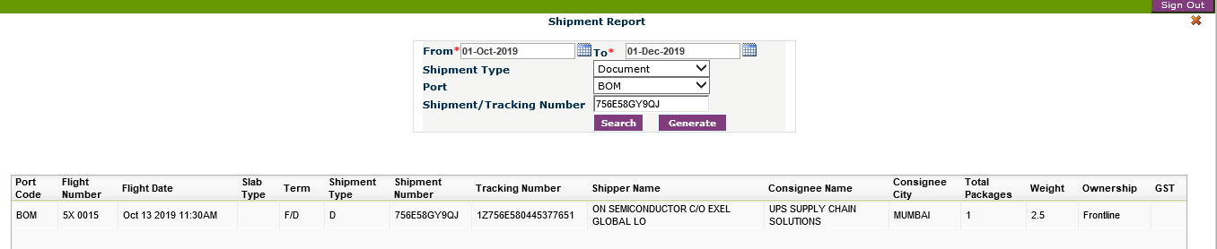

Agent Update report

* Update remarks by agents for any status update.

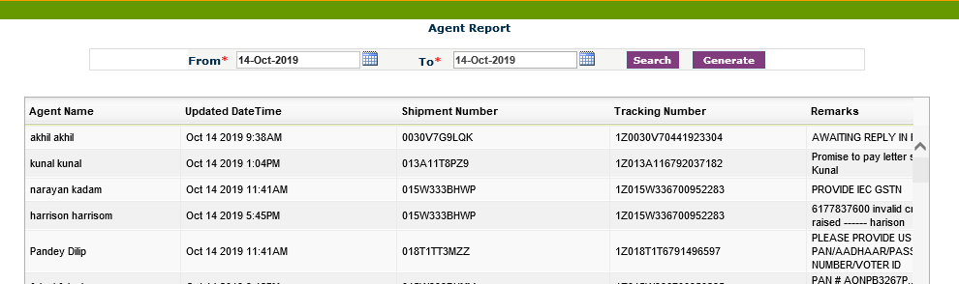

Brokerage dashboard

* Details of brokerage

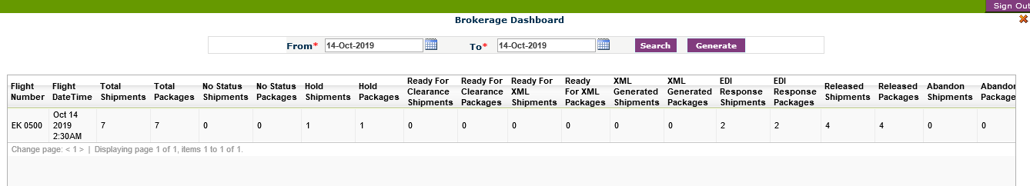

Billing Report

* Billing Details

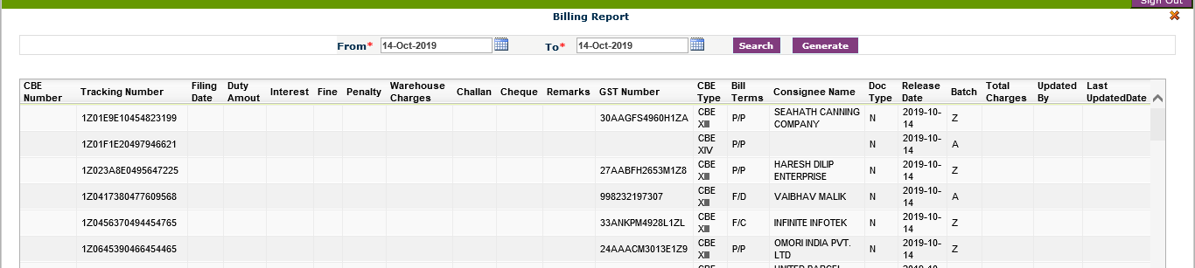

Detention report

* Details of all such consignments which are detained by customs and OOC is issued.

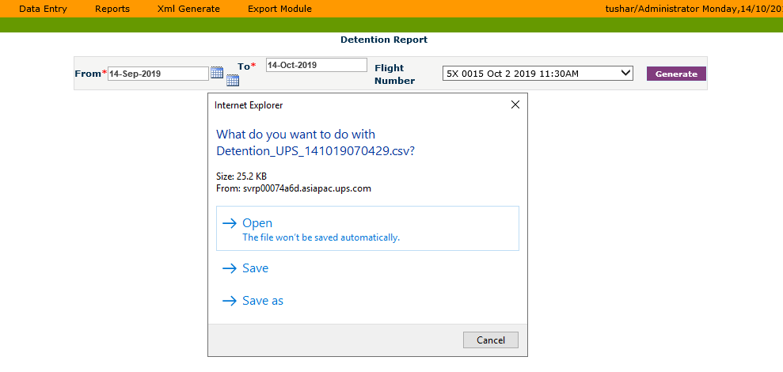

1. Export -

CSB 3,4,5 Reports

Export GST Report - ?

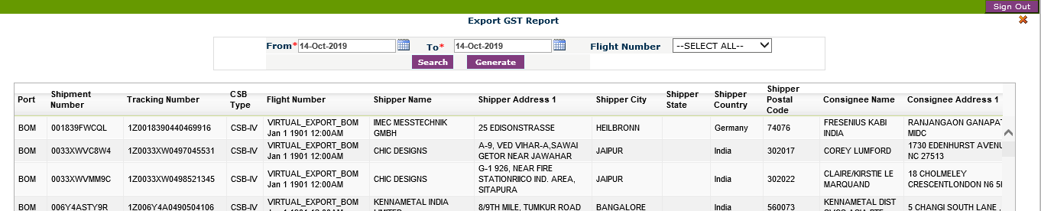

Shipment Report

* Shipment Details.

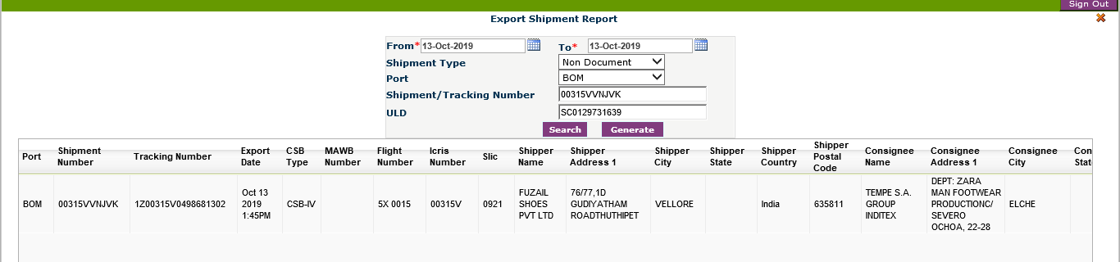

# **XML Generate**

Import - Generates XML for single shipment or for entire flight.

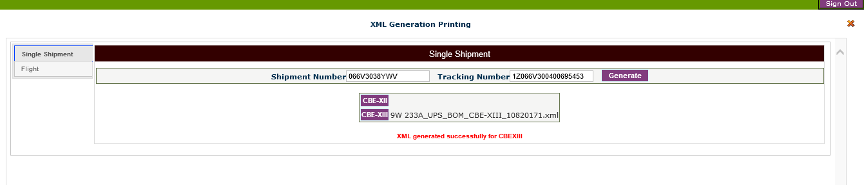

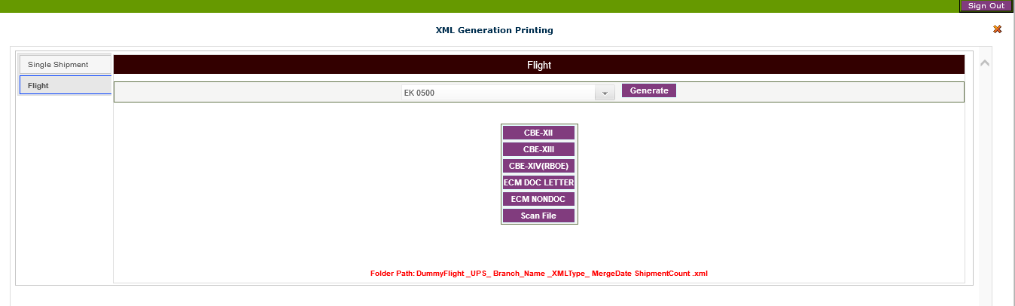

Import (Ready for XML)

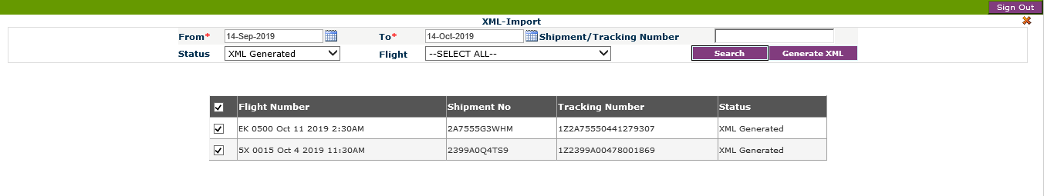

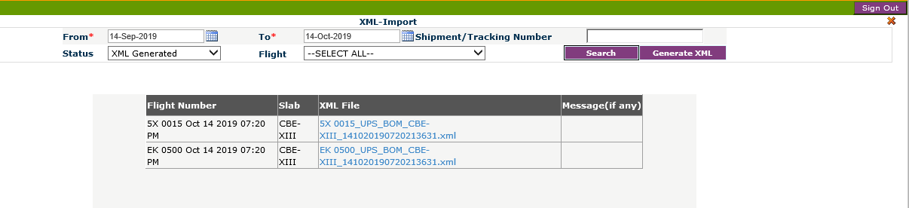

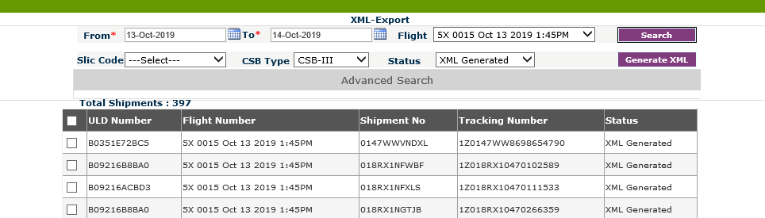

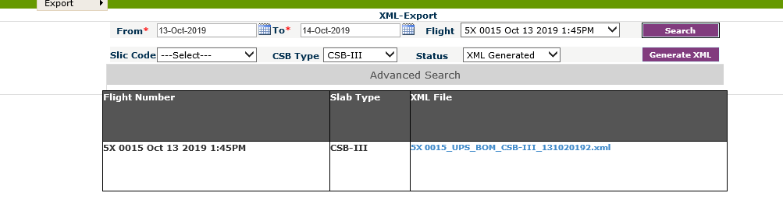

# **7 Export Module**

File Merge

This process includes uploading a Level1 file to IBCS and merging if for a Flight Number and Date

First of all key entry merge is uploaded , then tundra file merge is uploaded and finally missing tundra data is uploaded.

If we click on Merge flights then all the data is merged and populated into the SQL tables as per the information provided in CSV file.

Flight Process

A shipment can be transferred across the flights via this

DIS Integration

Click on the select flight and then merge. This displays list of invoices merged, pending etc.

Images are saved under New Folder>Images>Import Module/Export Module

If import then images are saved under >Port Name Folder (BLR/DEC/BOM)>Date Folder>Flight Name>Merge Files are saved

Flight Upload

It can upload CSB –4, 5. We can upload missing in the key entry, upload missing in tundra. This is similar to the file merge

Flight Update

This is used to up

# **8 Business impact**

* The system is aimed at enabling Custom Operations team to execute shipments through hassle-free customs process
* This system helps brokerage team to pre plan the import and export of shipment. It makes sure that all the shipments are reached on time without any issues caused due to custom process.
* At large, this system helps UPS India to deliver shipments on time while being compliant with customs regulations.